A6. Role of public finance

To build strong health systems based on primary health care for UHC and to secure financial protection for all people, robust, equitable financing systems are required. The modules that follow provide more detailed information and analysis; however, some concepts are introduced here.
Essential criteria for health financing for UHC are (28):
- automatic or mandatory entitlement: Population coverage should be automatic or mandatory, as a human right, with no obstacle or condition that determines entitlement, such as employment.
- compulsory and public financing: Compulsory contributions should be based on the ability to pay and unrelated to health care needs. Greater reliance on public funding will mean greater reliance on general government budget revenues (28). No country has attained universal population coverage by relying on voluntary contributions to insurance schemes.
- subsidization to minimize fragmentation: Resources for health must be pooled at scale under public oversight to reduce fragmentation.
- universal approach: The unit of analysis is the whole population, requiring a shift to an inclusive, universal system.
Key functions of health financing are revenue raising, pooling and purchasing (29). All countries have policies in which benefits are funded by government; in other countries, those that are not covered and paid for by patients through user fees (sometimes called “co-payments”). WHO has identified principles or signposts for each of the health financing sub-functions and policy areas (30):
- Revenue generation:
  - Move towards predominant reliance on public or compulsory funding sources (i.e. some form of taxation), reducing the share of total health spending from private or voluntary sources, and particularly out-of-pocket.
  - Increase the predictability of the level of public (and external) funding over several years.
  - Improve stability (i.e. regular budget execution) in the flow of public (and external) funds.
- Pooling:
  - Enhance the redistributive capacity of available prepaid funds.
  - Ensure explicit complementarity of different funding sources.
  - Reduce fragmentation, duplication and overlap.
  - Simplify financial flows.
- Strategic purchasing:
  - Increase the degree to which allocation of resources to providers is linked to population health needs, information on provider performance or a combination of the two.
  - Move away from the extremes of rigid, input-based line item budgets and completely unmanaged fee-for-service reimbursement.
  - Manage expenditure growth, for example by avoiding open-ended commitments in provider payment arrangements.
  - Move towards a unified data platform for patient activity, even if there are several health financing or health coverage schemes.
- Benefit design:
  - Clarify the population’s legal entitlements and obligations (who is entitled to what services and what, if anything, they are meant to pay at the point of use).
  - Improve the population’s awareness of both their legal entitlements and their obligations as beneficiaries.
  - Align promised benefits, or entitlements, with provider payment mechanisms.

Fig. 1 shows the UHC goals and intermediate objectives that are influenced by the health financing policy.

Fig. 1. UHC goals and intermediate objectives influenced by health financing policy

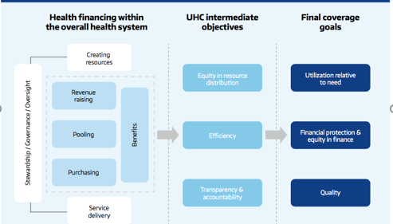

Source: reference 30.

