A2. What is the role of public resources in relation to public policy?

Fig. 3 summarizes the process for forming public policy. The government begins by defining the public problem (situation A) and the steps or actions to transform it (situation B). In this approach, resources are a key element for implementing activities, arriving at results and transforming the public problem. Resources are varied but they include financial resources; when it comes to public policy, the provision of human resources, material resources and other tools will also probably depend on financial resources.

Fig. 3. Process of forming public policy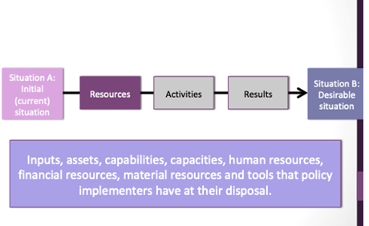

Source: reference 36.

In this process, the most obvious link between public policy and the public budget is that public policy cannot (or with great difficulty) be implemented without concrete financial resources, expressed in the budget as public expenditure. If order to analyse or measure the extent to which a particular policy is a priority for a given government, one can determine how much resources are allocated to it and how efficiently and effectively they are spent. For budget analysis, it is important that prospective budget advocates understand that public policy analysis accompanies (or should accompany) budget analysis, particularly for sector-specific research and advocacy.

