A3. On what should health policies focus in order for countries to achieve UHC?

In advocacy for UHC, it is important to understand what UHC means and the types of public policy choices it should entail. Module 1 in this section provides an overview of the content of UHC and is a good source for identifying the types of policies it should include. This module provides some ideas for advocates on aspects of UHC policies they should monitor to link public policy in general with public policy for UHC.
UHC means that all individuals and communities receive the health services that they need without suffering financial hardship. It includes the full spectrum of essential, quality health services, from health promotion to prevention, treatment, rehabilitation, and palliative care (13).
A strong health system is necessary to achieve effective, high-quality coverage:
Health systems and their strengthening are seen as the foundational set of policies, institutions, actions, approaches and tools, required to achieve the goals of UHC and the SDGs (34).
According to the WHO factsheet (13), UHC-related policies refer to actions linked to health systems strengthening that include:
- coverage;
- elimination of out-of-pocket expenses such as user fees;
- health promotion;
- disease prevention, treatment and rehabilitation;
- palliative care; and
- improvements in the quality of care.
By understanding what UHC is not, the types of policies necessary to achieve it can be identified in more detail.
Box 1 summarizes in the words of WHO (13) what does not constitute UHC.

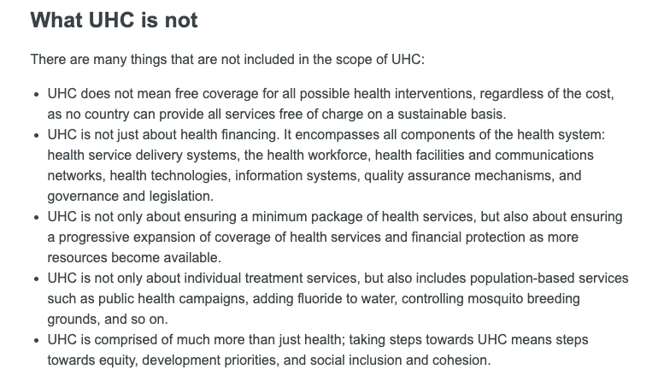

A few elements that might useful to consider with regard to UHC policy budgets are:
- Progressive extension of coverage and financial protection according to the availability of resources: thus, as more sources of public financing become available, coverage should be extended.
- Policies should include individual treatment; however, broader policies such as health campaigns and malaria prevention help prevent disease.
- Policies should go beyond health and health care per se.
WHO provides guidelines for monitoring and measuring UHC and, in collaboration with the World Bank, has published a framework for tracking progress towards UHC, with global UHC monitoring reports released biannually. The two main indicators in the framework are:
- the proportion of the population that can access essential, high-quality health services; and
- the proportion of the population that spends a large amount of household income on health.
The framework cites WHO’s 16 essential health services as indicators of equity and coverage, which are a good start for tracking advances towards UHC. They are also a good start for analysing public policies and budgets related to UHC:
Reproductive, maternal, newborn and child health:
- family planning
- antenatal and delivery care
- full child immunization
- health-seeking behaviour for pneumonia.
Infectious diseases:
- tuberculosis treatment
- HIV antiretroviral treatment
- hepatitis treatment
- use of insecticide-treated bed nets for malaria prevention
- adequate sanitation.
Noncommunicable diseases:
- prevention and treatment of raised blood pressure
- prevention and treatment of raised blood glucose
- cervical cancer screening
- tobacco (non-) smoking.
Service capacity and access:
- basic hospital access
- health worker density
- access to essential medicines
- health security: compliance with the International Health Regulations (2005).
For more information on the types of policies related to UHC, refer to module 1 in this section.

