B3. The revenue side of public expenditure on health and what is relevant for UHC budget advocacy

The sources of the public budget are either tax or non-tax revenues. The revenue sources of public expenditure for health are defined as follow in the System of health accounts 2011 (56):
  - compulsory or voluntary
  - prepaid or payment at the time of service use (out-of-pocket)
  - domestic or foreign.
From the perspective of health financing policy, public sources are those which are compulsory and pre-paid, while voluntary sources are considered private. Categorization of a source as compulsory implies that the government requires some or all people to make the payment, irrespective of whether they use health services. Thus, compulsory sources are also prepaid and are essentially the same as taxes. In this category, some of the most important distinctions are:
  - direct taxes paid by households and companies on income, earnings or profits directly to the government or another public agency; examples include income tax, payroll tax (including mandatory social health insurance contributions) and corporate income or profits taxes;
  - indirect taxes paid on what a household or company spends, not on what they earn, and paid indirectly to the government via a third party, e.g. a retailer or supplier. Common examples are value-added tax, sales taxes, excise tax on the consumption of products such as alcohol and tobacco and import duties;
  - non-tax revenues, e.g. from state-owned companies, including the “natural resource revenues” common in many mineral-rich countries, e.g. on oil and gas; and
  - financing from external (foreign) sources, typically categorized as “public” when these funds flow through recipient governments (see Box 2).
Taxes may also be regressive or progressive, but what does this mean? Depending on how they are applied and on how they account for the income of taxpayers, taxes can be regressive, progressive or proportional.
- A tax is regressive when it is in inverse relation to the income level of taxpayers. Regressive taxation imposes a greater tax burden on lower-income taxpayers.
- Progressive taxation increases the tax burden for taxpayers as their income increases; it allows for greater social progressivity and justice, as better-off citizens, i.e. those with a higher income, bear a higher tax burden.
- In proportional taxation, the amount of taxes levied on an individual is proportional to his or her income.

Understanding revenues in relation to UHC
Having committed themselves to achieving SDG 3, to “ensure health lives and promote well-being for all at all ages” (59), which includes SDG 3.8, to “achieve universal health coverage, including financial risk protection, access to quality essential health-care services and access to safe, effective, quality and affordable essential medicines and vaccines for all”, many countries will have to review and modify the way in which they finance health (51).
The previous section provided information for understanding how public budgets are financed in general terms. The sources of revenue for health vary and include public resources. The proportion of health that is financed by the public budget differs from country to country; however, in order for countries to achieve UHC progressively, they should try to derive most of their resources from public finance, as “no country has made significant progress towards UHC without relying on a dominant share of public funds to finance health” (51).
According to WHO (51), health financing
consists of the policies and arrangements that a country has for revenue sources and contribution mechanisms, pooling of funds, purchasing services, policies on benefit design, rationing, and the basis for entitlement and the governance of all of the above functions and policies.

How is health financed, and how does the public budget fit within this broad configuration?
Fig. 4, published by WHO in a guide for developing a national health financing strategy (50), is useful for understanding the different sources of revenue that finance health.

Fig. 4. Major sources of revenue and mechanisms for contribution
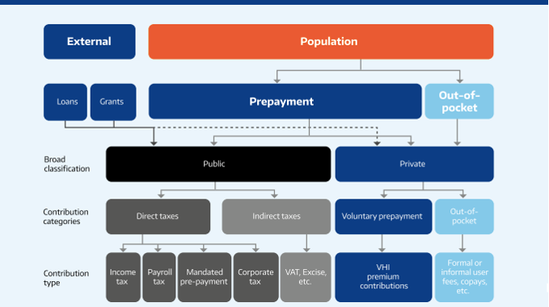

Source: reference 51

Broadly speaking and as seen in Fig. 4, health is financed from two sources: public and private. Public resources, which are the focus of this toolkit, are derived mainly from the following sources of revenue:
- External revenue from loans and grants: The vast majority of low-income countries rely on external sources of revenue to finance health, making them what is commonly known as “debt-dependent” or “aid-dependent”. An important aspect to consider and explore with respect to this source of revenue is whether the resources are incorporated into the public budget or are “off-budget”. If the resources flow outside the realm of the public budget, the general budget documents will not show how much and for what the resources are used. It is important to understand at this point that loans and grants obtained by a government are a key source of income for public health.
- Prepayment sources of revenue: These types of resources can finance both public health (health provided by and managed by the government) and private health (provided and managed by private entities). For the purposes of this toolkit and as per B3 above, the prepaid revenues that finance public health are of interest, as they should be reflected in the public budget. “prepaid contributions can take the form of taxes and either compulsory or voluntary health contributions.” For example, in some countries, like Mexico, a proportion of the income of formal workers included in the social security schemes is deducted, which is complemented by a contribution by the State that entitles them to health services provided by the Mexican Institute of Social Security.
- Different types of taxes: Fig. 4 shows a wide array of taxes that can levied on a population, which, once they flow through the public budget, can contribute to financing health. This illustrates why, for a strong health financing system, it is recommended that countries strengthen their internal revenue sources and why this may require a more robust fiscal policy. Many countries, however, find it difficult for various reasons (including political ones) to raise taxes. As mentioned before, who pays what taxes matters a lot and is a political decision.
Box 3 describes means for reducing out-of-pocket spending on health care.
Box 3. Out-of-pocket spending on health
One of the main objectives of moving towards UHC is to ensure that access to health does not impose financial hardship on the population, particularly the more disadvantaged.
WHO defines out-of-pocket spending as “direct payments made by individuals to health care providers at the time of service use.” Out-of-pocket spending is particularly prevalent in countries in which the health financing system relies heavily on user fees and co-payments, and it has a particularly devastating impact on the poor. This type of payment is common in countries in which health workers are not well paid, as it is a way for them to complement their wages.
In a UHC approach to health financing, countries move away from heavy reliance on out-of-pocket spending to ensure equitable access to health and to reduce financial hardship on the population. Out-of-pocket spending can be reduced by:
- abolishing formal and informal user fees and other charges in health facilities;
- applying policies that exempt vulnerable populations (for example, pregnant women, adolescents or the poor) from any payment for health services; and
- delivering key health services, such as maternal and child health, free of charge.

Source: reference 60

Impact of health financing from pooled funds on public finance
An important health financing function is referred to by health finance experts as “pooling” funds. Pooling “refers to the accumulation of prepaid revenues on behalf of a population and they are pooled by both public and private entities” (51). The WHO definition in the context of guiding governments in developing health financing strategies is (51):
Funds for health are pooled by a wide array of public and private agencies, including national ministries of health, decentralized arms of ministries of health, local governments, social health insurance funds, private for-profit and not-for-profit insurance funds, nongovernmental organizations (NGOs) and community organizations.
Pooling is an important concept for health budget advocacy for UHC, given the important role of the public budget in UHC. As suggested by the definition above, both national and subnational governments participate in or finance health through pooling mechanisms. For example, in decentralized health systems (61), as is the case in many countries, pooled funds are an important source of health financing, enhancing the role of both national and subnational budgets and the way in which they interact.
According to WHO (61), pooling revenues should result in the health financing strategy:
- enhancing the redistributive capacity of available prepaid funds;
- enabling explicit complementarity of different funding sources;
- reducing fragmentation, duplication and overlap; and
- simplifying financial flows.
Fig. 5, from the WHO national health financing strategy guide (51), shows common ways in which pooled funds flow from different sources, including private, into health. Box 4 shows the relation between budgets and UHC.

Fig. 5. Common revenue flows from sources to pooling entities
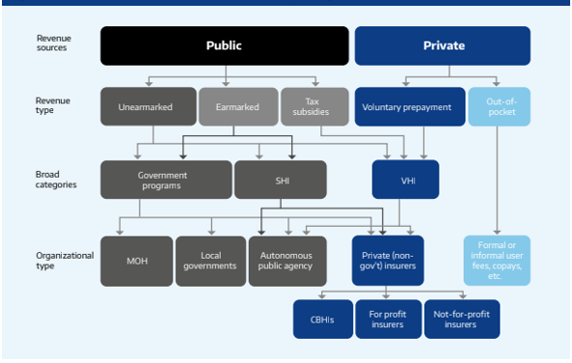
Source: reference 51
Box 4. The relevant relation between budget and UHC
There is a strong relation between the quality of budget systems and UHC.
- Robust public budgeting in health could improve predictability in the sector’s resources, which would increase the possibility of planning health policy actions.
- Proactive engagement of health ministries in the budget cycle facilitates alignment of budget allocations with sector priorities.
- When budgets are better designed, execution improves.
- If the health budget is formulated according to goals and the rules for execution are aligned with those goals, it will allow a certain degree of spending flexibility and make budgets more responsive to sector needs.
Source: reference 62

The resources included in revenue might be treated differently:
- On-budget. Allocations that are included in the budget;
- Off-budget. Allocations that are excluded from the budget by law and are financed by taxes or levies that are not in the budget (63).
“On-budget expenditure” follows the process and rules of the general budget; however, “off-budget expenditure” could present some obstacles for analysis, because it is usually more difficult to monitor and, in many countries, is used to finance health services and goods. See Box 5.

Box. 5. Off-budget health expenditure
The main form of off-budget health expenditure is off-budget funds, which are special funds owned by the government that are not part of the budget and that consist of earmarked levies and possibly other sources, such as fees and contributions from the general tax fund.
Earmarked levies are different from fees, as they do not reflect the market value of the services that are financed from the revenues.
Off-budget funds are found mainly for the areas of social security, health care, transport and pensions.
Government economic ownership of off-budget funds means that the government can dispose of the assets of the fund, if necessary by changing the law by which it was established, without compensation. The reasoning with respect to social security and public health care funds is that the premiums are paid by the social partners (employers and employed; patients) and that the funds thus “belong to them”, at least to the same degree as to the government. For the same reason, the social partners are often represented on the boards of the funds.
Source: reference 63

Thus, in analysing a health budget, it is important to know the origin of the resources for the health budget, the rules that apply to the expenditure and where sufficient information can be found. In the next sections, we provide some examples and exercises to better understand health expenditure and how to identify it.

