B5. Key budget classifications

The classification and organization of a budget are central to preparation of sector budget proposals (64). Budget classifications serve to categorize public expenditure in the annual budget law and thereby structure the budget presentation. They provide a normative framework for policy development and accountability (62). The main classifications and their applicability to health are summarized in Table 3.

Table 3. Main types of budget classification and their application to health
Budget classification
Economic | Classifies expenditure by economic categories (e.g. salaries, goods, services) To be consistent with the Government Finance Statistics Manual (GFSM)2001 economic classification (53). Economic classifications are often associated with input based or line item budgets.
Administrative | Classifies expenditures by administrative entities (e.g. agencies, health facilities) responsible for budget management
Functional | Categorizes expenditures by sector (e.g. health, education) Within each sector, subfunctions of expenditures (e.g. outpatient services, public health services) are further divided into classes (e.g. outpatient services include general medical services, specialized medical services, dental services and paramedical services). Categories have been pre-defined internationally for the purposes of comparison (53).
Programme | Classifies and groups expenditure by policy objective or outputs for the sector (e.g. maternal health, primary health care, quality of care) irrespective of their economic nature. Unlike other classifications this is meant to be country specific. Activity based classification e.g. provision of supplementary food has also been introduced in some countries prior or supplementary to larger budgetary programmes, as an effort to group expenditures into coherent policy actions (54).

Source: adapted from reference 62

The choice of budget classification is crucial for sectors because it pre-empts the underlying rules for budget implementation and plays a pivotal role in actual spending (62).
The choice is an important connection between PFM and health financing. Often, improvements in health financing and health budget information must be coupled with reforms in the public finance system so that budget information is better organized, classified, structured and presented. This ensures that health spending is not only more efficient and responsive to health needs and diagnostics but also more accountable.
The trend is to a more detailed, tailored approach for the UHC budget that relies more heavily on programmatic classification. Nonetheless, this transition is not easy, and it is better to move gradually to a complete programme-based budgeting reform. Fig. 6 shows some examples from countries that are moving in this direction.
Fig. 6. Input- and programme-based budgets: stylized examples for health

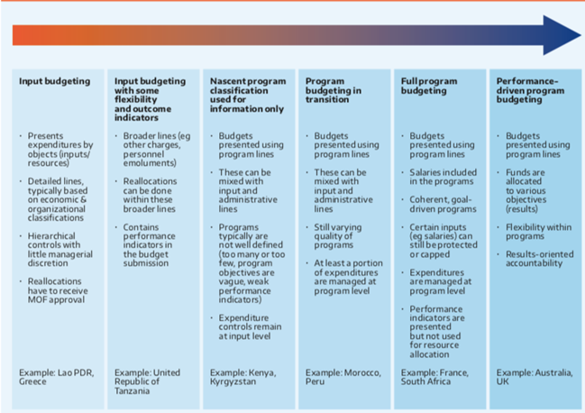

Source: reference 62
Note: The examples are for national budgeting. Countries do not fall neatly into these categories, as one may be transitioning from one to another.

Most countries use an additional budget classification: “programmatic classification”. A programme has been defined (65) as “a set of activities that meets specific policy objectives of the government (e.g. pre-primary education or the development of crop production)”.
Classification by programme is different from functional classification, as it accounts for the government’s policy objectives and how the policies will be implemented (65). Classification of expenditures by programme can serve two purposes:
- to identify and clarify the goals and objectives of government spending and
- to monitor operational performance with performance indicators, which may be related to the inputs, outputs or outcomes of a particular programme.

