C1. What is the budget cycle, and what are its key stages and actors?

The budget is designed, implemented and audited in stages, commonly known as “the budget cycle”, as shown in Fig. 7. The stages may be subdivided into steps according to the legal and institutional framework of each country; however, the cycle is used by most governments.

Fig. 7. The budget cycle
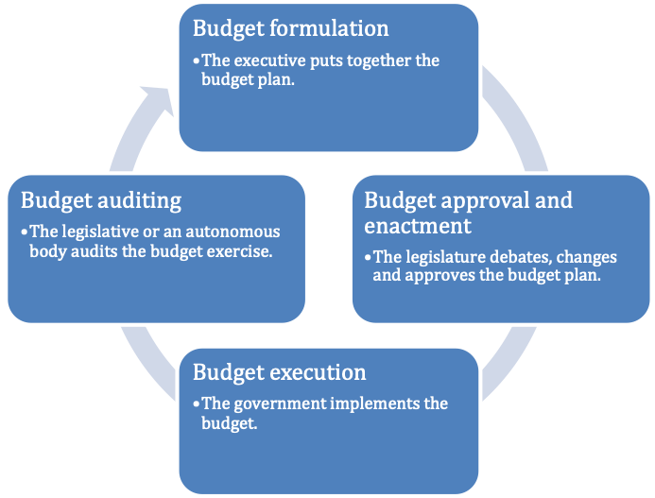
Source: reference 67

In order to influence the budget, it is important to understand the budget cycle of a country, the responsible authorities and their functions to engage in policy dialogue and monitoring of the budget at various stages (55, 64). In this toolkit, we use the “four-stake” budget cycle proposed by the IBP, as it is that which is more commonly used and referred to by the budget advocacy community of practice. This is not because it is the only budget cycle formulation, as there are other approaches.
During the formulation stage, the executive, through the ministry of finance, coordinates elaboration of the budget plan by requesting information from other line ministries. The ministry elaborates a draft budget after an analysis of the macroeconomic context, which includes government revenue, proposed budget ceilings and the priorities of all line ministries. This process may take several months, depending on the involvement of each ministry (55, 64).
Once the budget is formulated, the executive presents the budget to parliament for approval. Depending on the powers conferred on the legislature in the constitution of the country, this branch can approve, modify or make substantial changes to the budget. During this stage, the legislature reviews, debates and amends the draft budget plan and enacts the final budget into law. This stage is known as approval or enactment (55, 64).
Budget execution starts when the government spends financial resources according to the approved budget. During the fiscal year, the executive may modify the budget to meet unexpected situations. The extent to which the executive can change the budget should also be described in the legal framework (55, 64).
In the last stage, auditing, an independent agency or body reviews execution of the budget to determine whether the resources were used effectively and efficiently. Auditing also addresses the performance of line ministries in executing the budget. Generally, an autonomous audit institution (supreme audit institution) is charged with this duty, or the legislature may undertake auditing process (55, 64). The results of auditing represent a valuable input for designing the budget for the next year.

