Generation Equality Forum

Social Media Campaign
28-30 June 2021

Primary hashtags: #GenderUHC #GenerationEquality
Secondary hashtags: #HealthForAll #LeaveNoOneBehind #UHC2030 #ActForEqual
Accounts to tag and RT: @UHC2030, @PMNCH, @CSOs4UHC, @WomeninGH, @WomenDeliver, @UN_Women, @theglobalgoals

Additional handles:
@ippf, @UNFPA, @ARROW_Women, @youth_coalition, @chw_impact

Proposed Tweets

28 June

Theme #1: Access for women and girls – ensuring UHC is truly universal
There’s more to Universal Health Coverage than health. #UHC brings major social change and can help provide equal opportunities between genders. For #GenerationEquality, promote #GenderUHC. Learn more: https://bit.ly/3zWEJxg

We should all have access to quality services, regardless of sex, gender, age, race, religion or any other identifier. #GenderUHC #GenerationEquality https://bit.ly/3zWEJxg

To protect the most vulnerable women and girls, we must protect their right to health. #actforequal by promoting #GenderUHC. https://bit.ly/3zWEJxg

Theme #2: UHC must address all aspects of health, including sexual and reproductive health and rights

To #LeaveNoOneBehind, #UHC must consider the health needs of women and girls throughout their lives and must integrate sexual and reproductive health and rights. #SRHR #GenerationEquality #GenderUHC https://bit.ly/3zWEJxg

If we want to create #GenerationEquality, we need to make sure all women and girls receive the quality health services they need, including sexual and reproductive health services, without financial hardship. #GenderUHC #HealthForAll https://bit.ly/3zWEJxg

29 June

Theme #1: Women will deliver UHC as the majority of health workers

Women are 70% of the global health workforce and play a critical role in community care. For #GenerationEquality, let us invest in a well-trained and resourced health workforce that can deliver #GenderUHC to protect everyone. #ActForEqual https://bit.ly/3zWEJxg

Women are 70% of the health workforce but hold only 25% of senior roles. Their perspectives are vital in health decision-making at all levels from community to global to ensure UHC meets the needs of all genders. Promote #GenderUHC #GenerationEquality https://bit.ly/3zWEJxg

Theme #2: Women in leadership and decision making - not missing out on women’s knowledge and perspectives

Health is everyone’s business and rests on the full and effective participation of women at all levels to ensure countries build #healthsystems that protect everyone. #GenderUHC #ActForEqual #GenerationEquality https://bit.ly/3zWEJxg

Well-trained, well-paid health workers are the backbone of strong health systems for #UHC. Though women make up 70% of the global health workforce, they hold only 25% of senior roles. Invest in women leaders. #ActForEqual #GenerationEquality #GenderUHC https://bit.ly/3zWEJxg

30 June

Theme #1: Only gender responsive UHC meets the needs of all genders
We call on leaders and advocates to prioritise gender-responsive #UHC that meets the needs of ALL genders when defining investments and policies at the #GenerationEquality Forum. #GenderUHC Learn more: https://bit.ly/3zWEJxg

#UHC is critical for #genderequality. To protect the rights of all people to access health care, #UHC must consider the different health needs of women, men & non-binary people. Prioritise #HealthForAll. #LeaveNoOneBehind #GenerationEquality #GenderUHC https://bit.ly/3zWEJxg

Women need an equal say in the health systems that impact their health, rights and well-being. Keep #GenderUHC on the table at the #GenerationEquality Forum. #HealthForAll #ActForEqual l https://bit.ly/3zWEJxg

Theme #2: The secondary impacts of COVID-19 have disproportionately affected women and emphasized an immediate need to integrate decision-making for gender equality and health equity

The impacts of #COVID19 are often gendered. Women are 70% of the global health workforce and have been heavily affected by the pandemic. We need gender-responsive #UHC to protect women’s health and rights. #GenerationEquality #GenderUHC https://bit.ly/3zWEJxg

#COVID19 has widened gender inequality, with increased unpaid care falling on women, often at the expense of paid work. Advocate for gender-responsive #UHC that protects women’s health and rights. #GenerationEquality #GenderUHC https://bit.ly/3zWEJxg

Calls for Further Engagement

To truly #actforequal, we must protect the health of women and girls everywhere. Don’t let the pandemic take us backwards. #GenerationEquality #GenderUHC Learn more: https://bit.ly/3zWEJxg

Let’s improve #genderequality in the health and care workforce, so that women have safe, decent work and an equal say in decision-making. #actforequal #GenerationEquality #GenderUHC https://bit.ly/3zWEJxg

We must integrate the conversations around gender equality, #SRHR and health equity. One cannot be achieved without the other. Learn more about the Alliance for Gender and UHC: https://www.womeningh.org/uhc-gender #GenerationEquality #GenderUHC
To join the movement to achieve #HealthForAll, connect with @UHC2030 and its civil society engagement mechanism @CSOs4UHC: www.uhc2030.org #GenderUHC #GenerationEquality

The right to health includes the right to comprehensive sexual and reproductive health/#SRHR for all. #GenderUHC Learn more about the work of @PMNCH: www.pmnch.org

As we prepare for the next UN #HLM on #UHC in 2023, highlight and address how gender inequality affects health and #healthsystems. For universal health coverage, we need #GenerationEquality #GenderUHC.

Images:

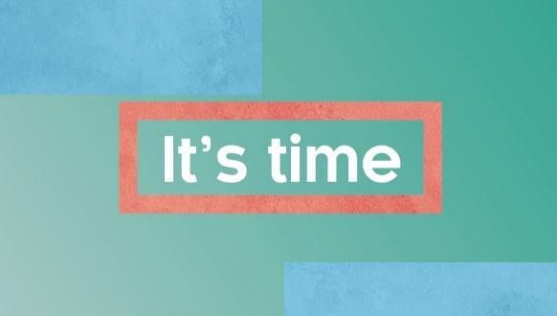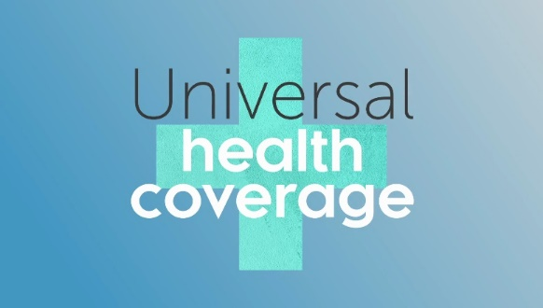

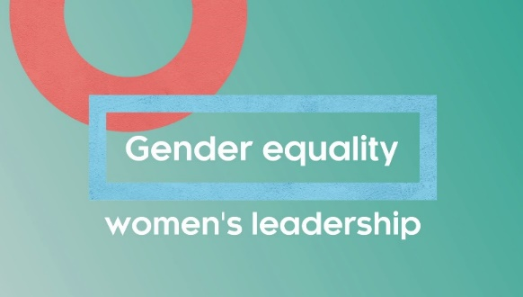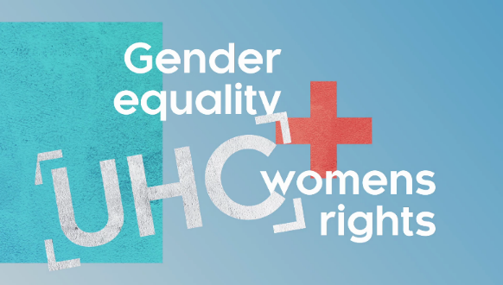
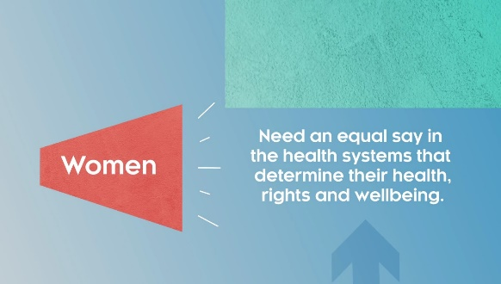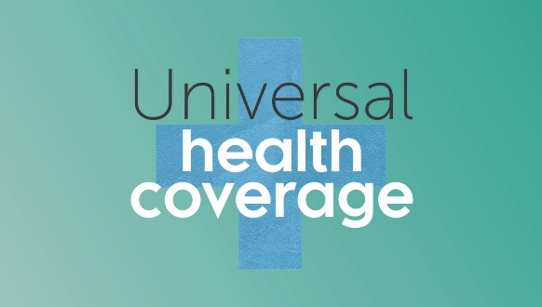

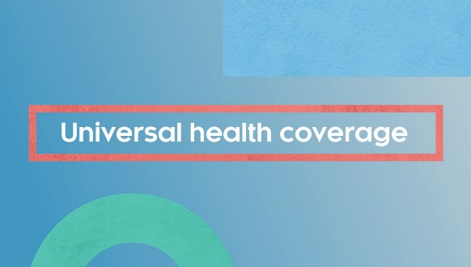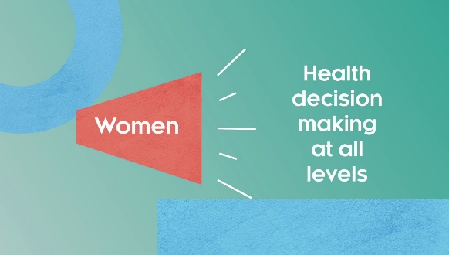

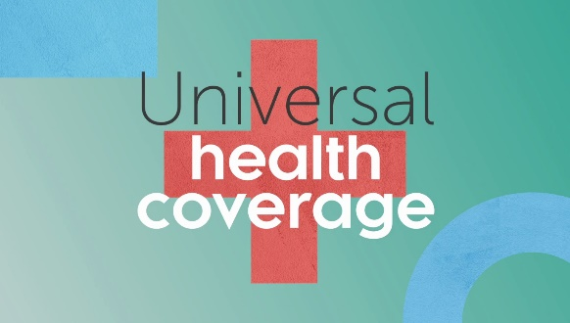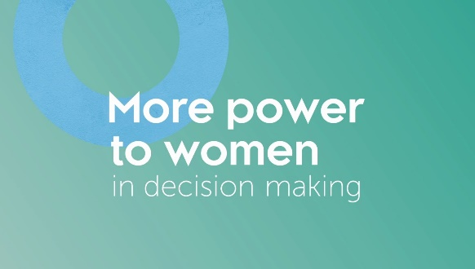

Quote cards:

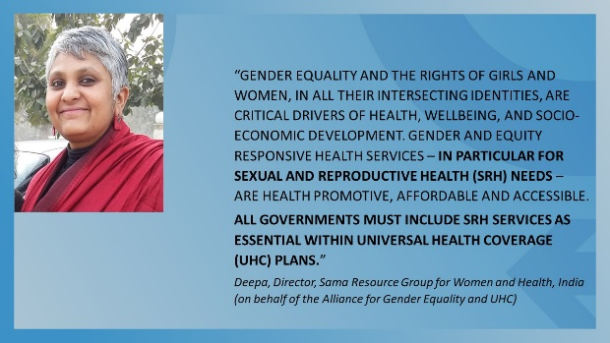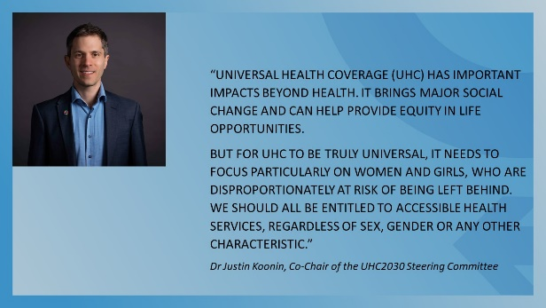

Or create your own image: Use this file to create a personal quote card:

